Logan Youth Football, INC. REGISTRATION FORM
Download forms by registering at www.loganyouthfootball.com
If mailing forms: LOGAN Youth Football 535 S 480 E Providence, UT 84332

School Attending 2024/25__________________________________________ Grade________________
Name of Player on Birth Certificate____________________________________ Gender ______________ Address_________________________________________________________ Date of Birth____________
City _______________________________________ Zip Code______________ Weight________________
Cell # _________________________ Home #________________________ Work #____________________
Parent/Legal Guardian Print Name ____________________________________________
Parent/Legal Guardian-Sign Name_____________________________________________ Date ______________
In an emergency, if legal guardian cannot be notified, please contact the following:
Name_____________________________________ Relationship ____________________ Ph. #______________
*Registration Fee for the 2024 season will be $280. This will include helmet and shoulder pad rental, and a new uniform which includes a jersey, pants, socks, and a game bag.

Jersey Size: _________ Pant Size: ____________ Sock Size: _____________

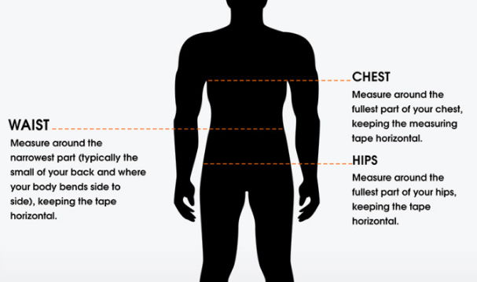
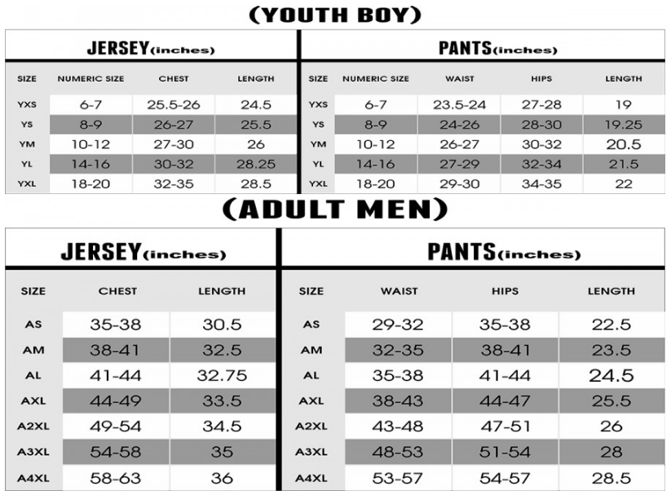
Sock Size:
If shoe size is 5 or smaller, order YOUTH size.
If shoe size is larger than 5, order ADULT size.

